附件三：
校外用户网上缴费流程图
1、登录网址: http://pay.nju.edu.cn
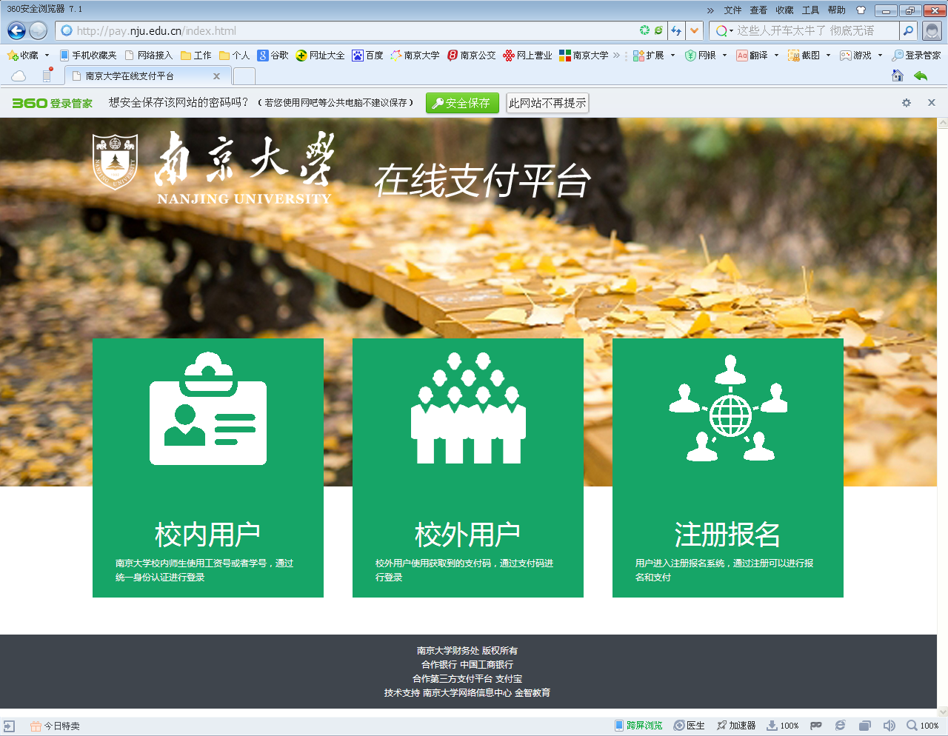
2、点中间“校外用户”。
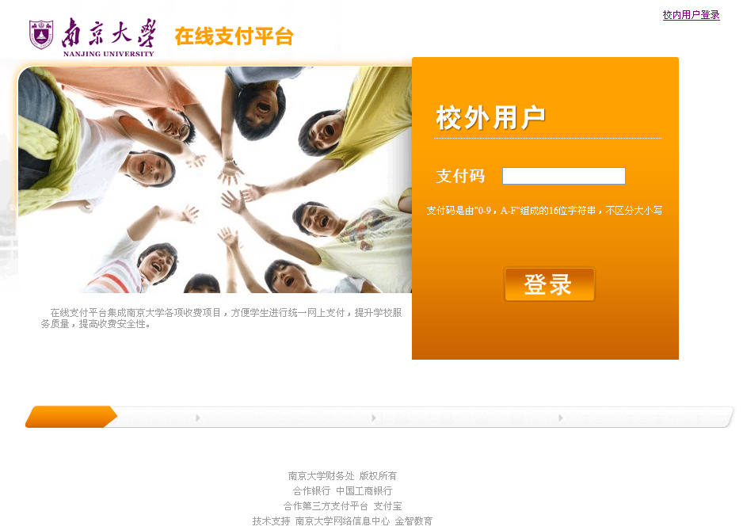
3、输入自己的16位包含字母和数字的支付码（密码）登录后，即可通过任一家银行网银支付，支付码（密码）见附件。

项目名称 | 人员编号 | 人员姓名 | 收费金额 | 密码
复试费 | 102847211501446 | 陈学智 | ¥80.00 | 6826DB164C536AAC
复试费 | 102847211501447 | 丁思凡 | ¥80.00 | 35311A6240B20D5B
复试费 | 102847211501449 | 梁勇 | ¥80.00 | 740ACEF2D03CB2B1
复试费 | 102847211501451 | 王晶 | ¥80.00 | 546890EB29EE2E4F
复试费 | 102847211501454 | 姚升 | ¥80.00 | 041D50F11A83C2E5
复试费 | 102847211501456 | 余帆 | ¥80.00 | 632D8F77F875D3C7
复试费 | 102847211501457 | 张留荣 | ¥80.00 | 9B0FC6B371B90B4C
复试费 | 102847211501460 | 周经建 | ¥80.00 | 2AF8897715D44673
复试费 | 102847211501467 | 钱啸明 | ¥80.00 | AF0B8EFC9BF6A354
复试费 | 102847211501474 | 武靖 | ¥80.00 | E6EBFAFF8487E57D
复试费 | 102847211501481 | 郝可 | ¥80.00 | 241B390ACFF38E56
复试费 | 102847211501483 | 刘力锋 | ¥80.00 | 9105F1FBFEF2C9D3
复试费 | 102847211501484 | 彭轶轩 | ¥80.00 | 51F7BB72EE1AD935
复试费 | 102847211501488 | 周敏 | ¥80.00 | 4FCCF085CC9BABFA
复试费 | 102847211501489 | 周云鹏 | ¥80.00 | 738B2B53FCEBE6BC
复试费 | 102847211501490 | 冯帅 | ¥80.00 | B86D4C9DE8A68548
复试费 | 102847211501491 | 金文武 | ¥80.00 | 945C18F2BF40E1BA
复试费 | 102847211501492 | 李倩倩 | ¥80.00 | 4E862199F68CCB66
复试费 | 102847211501494 | 李屹宇 | ¥80.00 | 69AFFD47CA3E3E52
复试费 | 102847211501495 | 栗璟 | ¥80.00 | CFA05EB6949B153C
复试费 | 102847211501496 | 刘宏 | ¥80.00 | 753468B861D729A8
复试费 | 102847211501498 | 马志良 | ¥80.00 | FB02878C6990A51F
复试费 | 102847211501499 | 王蓓蓓 | ¥80.00 | 9096BF9093029AC3
复试费 | 102847211501502 | 王温 | ¥80.00 | C3FE0D5FB5AE2C9F
复试费 | 102847211501503 | 王泽军 | ¥80.00 | B59409D5DCE1B865
复试费 | 102847211501504 | 张家赓 | ¥80.00 | 185BD195C81822CF
复试费 | 102847211501505 | 郑丹扬 | ¥80.00 | 368D328EB7A0B5A4
复试费 | 102847211501523 | 王威涵 | ¥80.00 | 1514F43A87A6CA55
复试费 | 102847211501558 | 何泽宇 | ¥80.00 | 46460055C023E5B5
复试费 | 102847211501559 | 居易白 | ¥80.00 | 0BA3C52DDA3895E4
复试费 | 102847211501562 | 夏邑芳 | ¥80.00 | DD1A999CCD7BBA27
复试费 | 102847211501563 | 张浩 | ¥80.00 | 0A63EB6C53E541C9
复试费 | 102847211501570 | 陈珂 | ¥80.00 | 301114546BAA667A
复试费 | 102847211501579 | 彭雨彤 | ¥80.00 | A91D94A4C8AECA8B
复试费 | 102847211501585 | 章雪 | ¥80.00 | 1F14E22070C61920
复试费 | 102847211505249 | 马富贵 | ¥80.00 | 0BCC6AC3A7C432EF
复试费 | 102847211505343 | 张燕如 | ¥80.00 | 47BE68A12019F942
复试费 | 102847211505415 | 孙钦善 | ¥80.00 | BF69769C3C3A6326
复试费 | 102847211505437 | 李壮壮 | ¥80.00 | FF33287367BC40A6
复试费 | 102847211505438 | 王德军 | ¥80.00 | 29E33670D688C8A4
复试费 | 102847211505521 | 黄苗苗 | ¥80.00 | 60F8031677712A81
复试费 | 102847211505568 | 任星宇 | ¥80.00 | 5C8B4417C94FA858
复试费 | 102847211506066 | 王杰 | ¥80.00 | FEDF3777134D5466
复试费 | 102847211506067 | 洪思聪 | ¥80.00 | 31BA8BDEDAAE1C7B
复试费 | 102847211506111 | 陈子豪 | ¥80.00 | 9D15501E0442BC46
复试费 | 102847211506197 | 周卓凡 | ¥80.00 | 84B82DECAFFD7666
复试费 | 102847211506326 | 张雨生 | ¥80.00 | CF12CD0D3868D846
复试费 | 102847211506533 | 安健 | ¥80.00 | 4B0FD2A7762D348C
复试费 | 102847211506534 | 吴茜茜 | ¥80.00 | 8FD43CADD5ABF836
复试费 | 102847211506535 | 闫婷婷 | ¥80.00 | 061A63577763DF2A
复试费 | 102847211506536 | 赵斐 | ¥80.00 | 4741CD6E37A81CB5
复试费 | 102847211506537 | 刘丹丹 | ¥80.00 | 434D336C330E8B51
复试费 | 102847211506716 | 刘城 | ¥80.00 | A5219C4BFA16DD21
复试费 | 102847211506755 | 张芷毓 | ¥80.00 | 5DB4979CF2D4B41C
复试费 | 102847211506931 | 盛文杰 | ¥80.00 | 2116D3C92A063A0B
复试费 | 102847211507083 | 刘敬文 | ¥80.00 | F22B2305BF0F9735
复试费 | 102847211507293 | 翁天一 | ¥80.00 | 704DF4A3D888C6B4
复试费 | 102847211507548 | 顾梦影 | ¥80.00 | 015998B39CAEB1D5
复试费 | 102847211508013 | 刁敏敏 | ¥80.00 | C4021FE1A3DA2262
复试费 | 102847211508015 | 李亭杉 | ¥80.00 | 1795253144519DCC
复试费 | 102847211508600 | 戈好雨 | ¥80.00 | 76F32481B7393BF2
复试费 | 102847211508601 | 潘万腾 | ¥80.00 | 94721216DD82F51D
复试费 | 102847211508949 | 顾茂青 | ¥80.00 | F4BD9DF26D5BEC9D
复试费 | 102847211508950 | 沈杰 | ¥80.00 | A341B287F69D895D
复试费 | 102847211508951 | 王黎明 | ¥80.00 | 073408EF93A2A6DB
复试费 | 102847211509153 | 王敏捷 | ¥80.00 | 17956A35FEECA24A
复试费 | 102847211509319 | 王可 | ¥80.00 | 83B122B2E765A954
复试费 | 102847211509769 | 王琅 | ¥80.00 | 650C3A04E9607B70
复试费 | 102847211509770 | 王梦麟 | ¥80.00 | E8D982F300061A72
复试费 | 102847211509772 | 张杰 | ¥80.00 | 3C84C7C5998D475A
复试费 | 102847211509773 | 季夏冰 | ¥80.00 | CAC21EF8F82D6D40
复试费 | 102847211510207 | 朱冰清 | ¥80.00 | 5749F83B63F1D646
复试费 | 102847211510212 | 姚涛 | ¥80.00 | CF148C227135DAA3
复试费 | 102847211510410 | 李旭 | ¥80.00 | 840C6EC4C9626A34
复试费 | 102847211510411 | 潘雷刚 | ¥80.00 | 46D47DBD1D6F69A6
复试费 | 102847211510412 | 万敏 | ¥80.00 | 83CE64BB0C1F7F61
复试费 | 102847211510570 | 潘孝成 | ¥80.00 | 2CFE0E69CD859668
复试费 | 102847211511160 | 陆伟伟 | ¥80.00 | D25526356B61144C
复试费 | 102847211511553 | 夏志伟 | ¥80.00 | 0381E80C4EFCE142
复试费 | 102847211511554 | 徐桥 | ¥80.00 | 34CA8D398E5AC47F
复试费 | 102847211511637 | 盛中祥 | ¥80.00 | 11A431A87B49FB44
复试费 | 102847211511638 | 张登璨 | ¥80.00 | 86EF12CD01CE55BB
复试费 | 102847211511921 | 王轲 | ¥80.00 | 486F3FB1FBDD0E43
复试费 | 102847211512118 | 曹李斌 | ¥80.00 | 27AF51151CB10869
复试费 | 102847211512238 | 胡晓斌 | ¥80.00 | F2FF19AC976AB5DB
复试费 | 102847211512464 | 董范范 | ¥80.00 | 37054E709E20C8D1
复试费 | 102847211512650 | 李梦迪 | ¥80.00 | 23416C8D771E46FA
复试费 | 102847211512651 | 孙天宇 | ¥80.00 | 4793F34DBFC88332
复试费 | 102847211512652 | 郭小奇 | ¥80.00 | 82F37025CD891F77
复试费 | 102847211512796 | 郑磊 | ¥80.00 | B099AEFFAAA66398
复试费 | 102847211513360 | 李鹏勇 | ¥80.00 | 2A705D1EAE73DB65
复试费 | 102847211513361 | 王海芳 | ¥80.00 | 38825B99725ED583
复试费 | 102847211513491 | 许明玉 | ¥80.00 | E5D0B66FE200ADF6
复试费 | 102847211513537 | 史文聚 | ¥80.00 | FDAD03AE3EAE065F
复试费 | 102847211513588 | 孙超 | ¥80.00 | D60A1BEDC6028A5A
复试费 | 102847211513655 | 赵晓菲 | ¥80.00 | AAAB145BEA0EE10F
复试费 | 102847211513780 | 李登峰 | ¥80.00 | 2FBDDE76C0D8B2BD
复试费 | 102847211514027 | 马梦园 | ¥80.00 | A417D5093F122F4C
复试费 | 102847211514236 | 李强 | ¥80.00 | 354FA1410ADF48D7
复试费 | 102847211514464 | 卫岂伦 | ¥80.00 | FB9359D88EADA20B
复试费 | 102847211514520 | 曹中造 | ¥80.00 | 0BE4A5E6872E51BD
复试费 | 102847211514521 | 喻雅洁 | ¥80.00 | 2311DB68744B6E21
复试费 | 102847211514712 | 甘名喻 | ¥80.00 | E175AE169F8712EF
复试费 | 102847211514831 | 姚成辉 | ¥80.00 | B867852146E11777
复试费 | 102847211515182 | 刘婧宇 | ¥80.00 | C76B5E450DA91FA3
复试费 | 102847211515458 | 林俊安 | ¥80.00 | 3DFE9E2869A513EB
复试费 | 102847211515459 | 杨茹 | ¥80.00 | F490F649B130C0BA
复试费 | 102847211515783 | 白尧 | ¥80.00 | 89ABA64DB6C287FD
复试费 | 102847211515784 | 闵应雄 | ¥80.00 | 18F1D42C34A5C83C
复试费 | 102847211515840 | 曾小丫 | ¥80.00 | 2F484D16FF3392F1
复试费 | 102847211515966 | 袁芬芬 | ¥80.00 | 605BDAA472C7391E
复试费 | 102847211516235 | 徐亚文 | ¥80.00 | D8275AE36A0D80CC
复试费 | 102847271505000 | 戴迪 | ¥80.00 | 95F8B7DCEDF1622A

